787 Seventh Avenue

New York, NY 10019-6099

Tel: 212 728 8000

Fax: 212 728 8111

December 3, 2012

VIA EDGAR CORRESPONDENCE FILING

Mr. Jim B. Rosenberg

Senior Assistant Chief Accountant

Securities and Exchange Commission

100 F Street, N.E.

Washington, D.C. 20549

Re: Fidelity National Financial, Inc., File No. 001-32630

Dear Mr. Rosenberg:

On behalf of Fidelity National Financial, Inc. (“FNF”), we hereby submit the following responses to the comment letter dated November 20, 2012, from the Staff (the “Staff”) of the Securities and Exchange Commission (the “Commission”) relating to the Form 10-K for the Fiscal Year Ended December 31, 2011 and the Form 10-Q for the Quarterly Period Ended September 30, 2012 of FNF. To assist your review, we have retyped the text of those comments below.

Form 10-K for the Fiscal Year Ended December 31, 2011

Management’s Discussion and Analysis of Financial Condition and Results of Operations

Critical Accounting Estimates

Reserve for Claims Losses, page 29

- Because IBNR reserve estimates are more imprecise, please provide revised proposed disclosure to be included in future filings to disclose the amount of IBNR separately from known claims.

The Company notes the Staff’s comment and proposes to include the following table in its critical accounting policy with respect to the Reserve for Claim Losses for its Fidelity National Title Group segment in future filings:

NEW YORK WASHINGTON PARIS LONDON MILAN ROME FRANKFURT BRUSSELS

in alliance with Dickson Minto W.S., London and Edinburgh

December 3, 2012

Page 2

The table below summarizes our reserves for known claims and incurred but not reported claims related to title insurance.

 | As of |  |  |  |  |  |  |  | As of
 | December 31, 2012 |  |  |  | % |  |  |  | December 31, 2011 |  |  | %
 |  |  |  |  |  | (In millions)
Known Claims |  | [$ | ] |  | [ | %] |  |  | [$ | ] | [ |  | %]
IBNR |  | [ | ] |  | [ | ] |  |  | [ | ] | [ |  | ]
Total Reserve |  | [$ | ] |  | 100.0% |  |  |  | [$ | ] |  | 100.0%

Notes to Consolidated Financial Statements

Note L. Regulation and Equity, page 78

- Please provide us proposed disclosure to be included in future filings to address the following:

- Although you disclose that each of your insurers has complied with the minimum statutory requirements, please disclose the amount of statutory capital and surplus necessary to satisfy regulatory requirements if significant in relation to the entity’s statutory capital and surplus, as required under ASC 944-505-50-1b. If not significant, please clarify in the disclosure.

The Company holds four insurers, each of which is required by statute to hold a minimum amount of statutory capital and surplus. The minimum required statutory capital and surplus and actual statutory capital and surplus for each insurer as of December 31, 2011 is as follows:

 |  |  |  |  | Required Statutory
 | Minimum Required |  |  |  | Capital Surplus as a %
 | Statutory Capital and |  | Total Capital and Surplus as |  | of Actual Total Capital
 | Surplus |  | of December 31, 2011 |  | and Surplus
Fidelity National Title Insurance Company | $1,000,000 |  | $235,644,000 |  | 0.4%
Chicago Title Insurance Company | 2,000,000 | 639,453,000 |  | 0.3%
Commonwealth Land Title Insurance Company | 2,000,000 | 192,952,000 |  | 1.0%
Alamo Title Insurance | 2,000,000 | 19,589,000 |  | 10.2%

December 3, 2012

Page 3

As the required statutory capital and surplus are not significant to each entity’s actual statutory capital and surplus, these amounts were not previously disclosed. The Company proposes the following disclosure in future filings to clarify:

Pursuant to statutory requirements of the various states in which our insurers are domiciled, such insurers must maintain certain levels of minimum capital and surplus. Required levels of minimum capital and surplus are not significant to the insurers individually or in aggregate. Each of our insurers has complied with the minimum statutory requirements as of December 31, 20XX.

- Disclose the amount of retained earnings that is restricted or free of restriction for the payment of dividends to your stockholders. Refer to Rule 4-08(e) of Regulation S-X.

As of December 31, 2011, there were no restrictions on the Company’s retained earnings regarding the ability to pay dividends to its stockholders. The Company is a party to a credit agreement with Bank of America, N.A. with a total borrowing capacity amount of $951.2 million at December 31, 2011 (the “Credit Agreement”). The Credit Agreement contains restrictions on payment of dividends if an event of default has occurred and is continuing or would result from paying such dividend. Also, our ability to pay dividends to our stockholders is restricted by the ability of our wholly owned insurance companies to pay dividends to the Parent company. The Company believes it has complied with the requirements of Rule 4-08(e) of Regulation S-X by including the following disclosures in the Notes to Consolidated Financial Statements, Note H. Notes Payable (page 70) and Note L. Regulation and Equity (page 79):

Note H. Notes Payable (page 70):

Effective March 5, 2010, we entered into an agreement to amend and extend our credit agreement dated September 12, 2006 (the “Credit Agreement”) with Bank of America, N.A. as administrative agent and swing line lender (the “Administrative Agent”), and the other financial institutions, and an agreement to change the aggregate size of the credit facility under the Credit Agreement. These agreements reduced the total size of the credit facility from $1.1 billion to $951.2 million, with an option to increase the size of the credit facility to $1.1 billion, and created a new tranche, representing $925.0 million of the total credit facility, with an extended maturity date of March 5, 2013. Pricing for the new tranche is based on an applicable margin between 160 basis points to 240 basis points over LIBOR, depending on the senior debt ratings of FNF, and is at 200 basis points over LIBOR as of December 31, 2011. The Credit Agreement remains subject to affirmative, negative and financial covenants customary for financings of this type, including, among other things, limits on the creation of liens, sales of assets, the incurrence of indebtedness, restricted payments, transactions with affiliates, and certain amendments. The Credit Agreement prohibits us from paying dividends to our stockholders if an event of default has occurred and is continuing or would result therefrom. The Credit Agreement requires us to maintain certain financial ratios and levels of capitalization. The Credit Agreement includes customary events of default for facilities of this type (with customary grace periods, as applicable). These events of default include a cross-default provision that, subject to limited exceptions, permits the lenders to declare the Credit

December 3, 2012

Page 4

Agreement in default if: (i) (A) we fail to make any payment after the applicable grace period under any indebtedness with a principal amount (including undrawn committed amounts) in excess of 3% of our net worth, as defined in the Credit Agreement, or (B) we fail to perform any other term under any such indebtedness, or any other event occurs, as a result of which the holders thereof may cause it to become due and payable prior to its maturity; or (ii) certain termination events occur under significant interest rate, equity or other swap contracts. The Credit Agreement provides that, upon the occurrence of an event of default, the interest rate on all outstanding obligations will be increased and payments of all outstanding loans may be accelerated and/or the lenders’ commitments may be terminated. In addition, upon the occurrence of certain insolvency or bankruptcy related events of default, all amounts payable under the Credit Agreement shall automatically become immediately due and payable, and the lenders’ commitments will automatically terminate.

Note L. Regulation and Equity (page 79):

Our insurance subsidiaries are subject to regulations that restrict their ability to pay dividends or make other distributions of cash or property to their immediate parent company without prior approval from the Department of Insurance of their respective states of domicile. As of December 31, 2011, $2,203.3 million of our net assets are restricted from dividend payments without prior approval from the Departments of Insurance. During 2012, our title insurers can pay or make distributions to us of approximately $107.6 million, without prior approval.

There were no other restrictions on the ability to pay dividends to stockholders at the parent or subsidiaries as of December 31, 2011 as prescribed by Rule 4-08(e) of Regulation S-X. We will re-evaluate the existence of any restrictions on the payment of dividends to the Company’s stockholders at December 31, 2012 and disclose any such restrictions in our Form 10-K accordingly.

• Provide the disclosure required under ASC 944-505-50-6, as applicable.

Title Insurance Companies are not required to and do not calculate risk based capital.

Form 10-Q for the Quarterly Period Ended September 30, 2012

Notes to Condensed Consolidated Financial Statements

Note A – Basis of Financial Statements, page 6

- Please tell us the nature of the error and why you have not reported it as a correction of an error. The amount appears material for each period to your cash flows from operating and investing activities. Refer to ASC 250 and Staff Accounting Bulletin 99.

In connection with the preparation of the first quarter 2012 cash flow statement, the Company identified a misclassification between operating activities and investing activities in which certain unsettled investment transactions as of the quarter-end were improperly included in cash flows from operating activities. The error was identified due to unusual fluctuations in the change in accounts

December 3, 2012

Page 5

payable and other liabilities line of the cash flow statement. The result was that cash flows from operating activities and cash flows from investing activities were misstated for each of the quarters ending in 2011 as well as the year ending December 31, 2011. The impact of this error for each quarter in 2011 and the years presented in the Form 10-K filed for the ended December 31, 2011 are as follows:
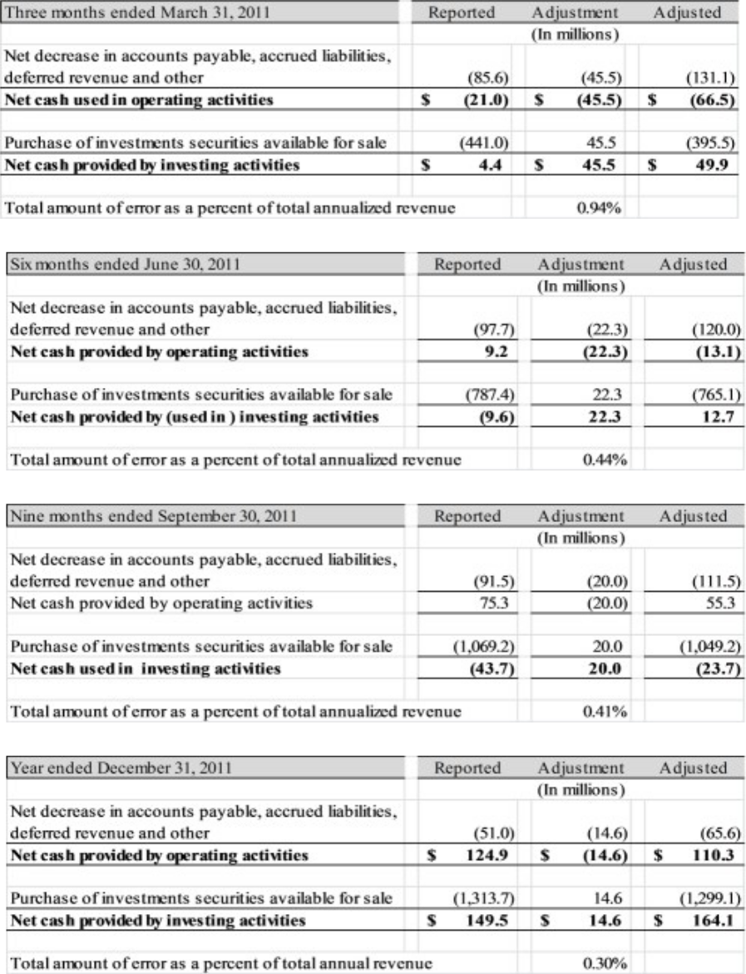

December 3, 2012

Page 6
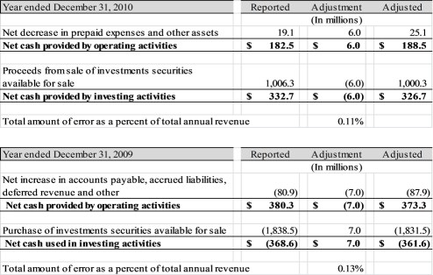

As part of the preparation of the first quarter 2012 Form 10-Q, the Company considered the materiality of the error, and considered the guidance provided by ASC 250 and Staff Accounting Bulletin 99 (SAB 99), in particular considering whether “The omission or misstatement of … in the light of surrounding circumstances…is such that it is probable that the judgment of a reasonable person relying upon the report would have been changed or influenced by the inclusion or correction of the item.” (SAB 99, Section M 1.)

The Company reviewed the misstatement for each quarterly period in 2011 and for each period presented in the 2011 10-K (the most recent on file) on a quantitative and qualitative basis.

From a quantitative standpoint, the Company uses a materiality threshold of 0.5% of annual revenue as a “rule of thumb” or preliminary assessment of materiality and determined the errors were not material for any period other than Q1 2011 based on a quantitative threshold of 0.5% of annual revenue

The Company also considered several qualitative factors. Operating cash flows for the first quarter is not a significant financial measure as it is not indicative of the full year operating cash flows. During the first quarter, the Company settles year-end liabilities, most significantly the Company’s annual bonus payout, which relates to the prior year and not the first quarter performance. The correction of the errors does not impact cash flow trends for historic periods. The first quarter generally shows a net cash outflow from operations while other quarters generally show a cash inflow from operations. To the extent that investors are focused on operating and investing cash flows, investors would generally look to the full year since seasonality impacts quarterly trends.

December 3, 2012

Page 7
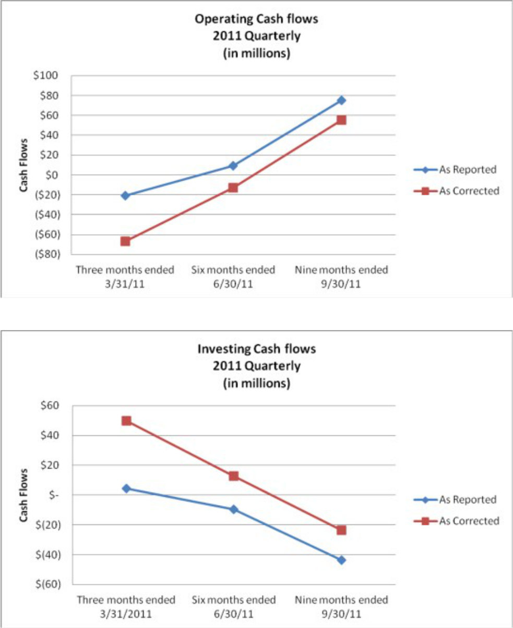

December 3, 2012

Page 8
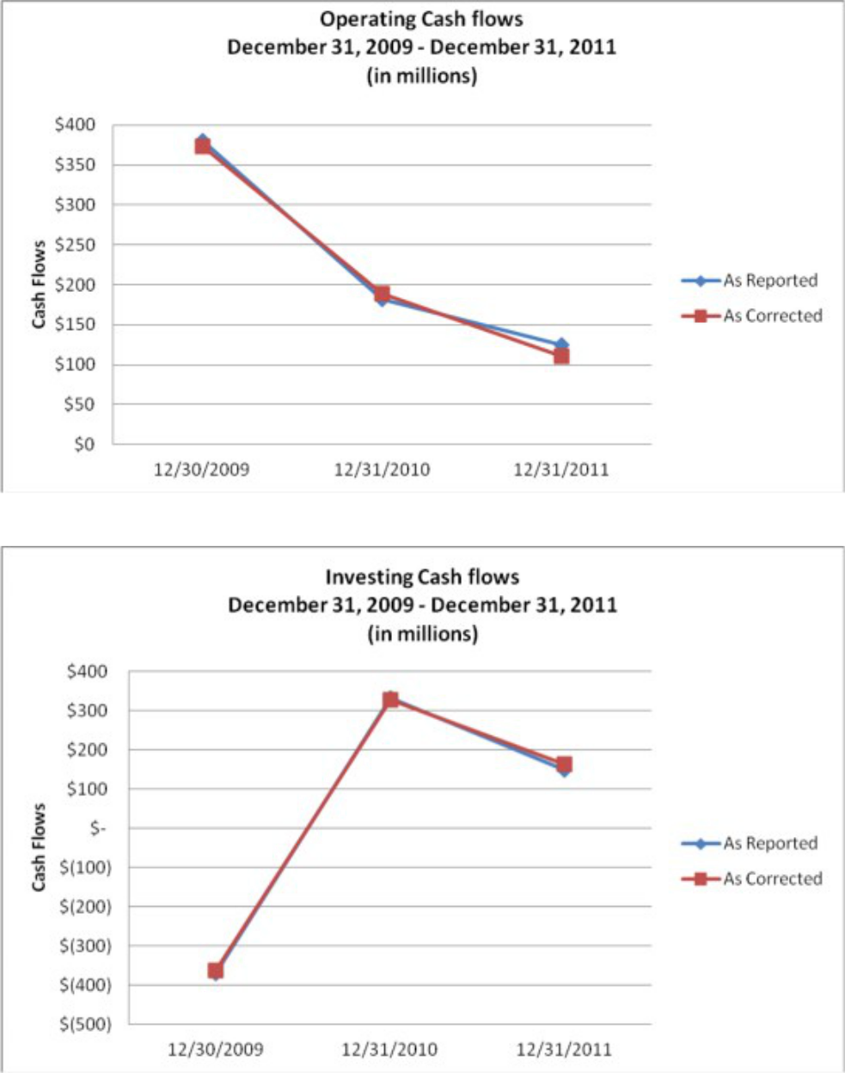

In non-insurance public companies, cash flow from operations is often used by financial statement users to determine the Company’s dividend paying capacity as well as its capital expenditure potential. As an insurance company, dividend capacity and capital expenditure potential are dependent on the statutory dividend paying capacity at our insurance subsidiaries, which is dependent on statutory net

December 3, 2012

Page 9

income and statutory surplus, both of which are unaffected by GAAP cash flows from operations. The Company clarifies the nature of its cash flows and the impact on dividend paying capacity within the Liquidity and Capital Resources section of the 10-K, which reads as follows for the year ending December 31, 2011 (page 40):

We believe that all anticipated cash requirements for current operations will be met from internally generated funds, through cash dividends from subsidiaries, cash generated by investment securities, potential sales of non-strategic assets, and borrowings on existing credit facilities.

Also, in the past, investor groups, creditors, financial analysts and other financial statement users have placed little emphasis on the Company’s cash flows from operations. The Company is not currently measured by any external analysts by its cash flows from operations. Operating cash flows are not discussed significantly in the Company’s earnings releases or management discussion and analysis in the Form 10-K. Also, to the extent that investors are focused on operating and investing cash flows, investors would generally look to the full year since seasonality impacts quarterly trends. The Company fully disclosed this seasonality within the Liquidity and Capital Resources section of the 10-K, which reads as follows for the year ending December 31, 2011 (page 42):

Historically, real estate transactions have produced seasonal revenue levels for title insurers. The first calendar quarter is typically the weakest quarter in terms of revenue due to the generally low volume of home sales during January and February. The third calendar quarter has been typically the strongest in terms of revenue primarily due to a higher volume of home sales in the summer months and the fourth quarter is usually also strong due to commercial entities desiring to complete transactions by year-end.

Further, the error would not have affected any compliance with regulatory requirements, debt covenants, or affected management compensation. In considering the origin of the error, the Company noted it was merely an oversight resulting in the non-cash transaction being recorded as cash flows in the operating section of the statements cash flows and offsetting cash flows in the investing section and did not result from any intentional misstatement.

After consideration of these quantitative and qualitative factors and the authoritative guidance of ASC 250 and Staff Accounting Bulletin 99, the Company concluded that the correction of the cash flow classification error between operating and investing activities was not material to the financial statements as we do not believe it is probable that the judgment of a reasonable person relying upon the report would have been changed or influenced by the correction of this item The immaterial error was corrected in each of the quarterly financial statements for 2012 and will be corrected in the 10-K to be filed for the year ending December 31, 2012. The following disclosure will be included in the 10-K to be filed for the year ending December 31, 2012:

Certain reclassifications have been made in the 2011 Consolidated Financial Statements to conform to classifications used in 2012. In addition, we have corrected an immaterial prior period error in the Consolidated Statement of Cash Flows. The correction was between cash flows from operating activities and cash flows from investing activities for the years ending December 31, 2011 and 2010. The correction resulted in a decrease in cash provided by

December 3, 2012

Page 10

operating activities and an increase in cash provided by investing activities of $14.6 million in 2011 and an increase in cash provided by operating activities and a decrease in cash provided by investing activities of $6.6 million in 2010. There was no impact on our other Consolidated Financial Statements presented.

Further, FNF acknowledges that:

– FNF is responsible for the adequacy and accuracy of the disclosure in the filings;

– Staff comments or changes to disclosure in response to Staff comments do not foreclose the Commission from taking any action with respect to the filings; and

– FNF may not assert Staff comments as a defense in any proceedings initiated by the Commission or any person under the federal securities laws of the United States.

We would appreciate receiving any further comments at the Staff’s earliest possible convenience. If you should have any questions or comments regarding this letter, please contact me at 212-728-8088 or my colleague, Joshua Halpern, at 212-728-8540.

Very truly yours,

/s/ Robert S. Rachofsky

Robert S. Rachofsky

